**Flight Booking Jade Database Documentation**

By: Kaue Reis Assis Pereira and Alex Simmons

**Introduction:**

We have been tasked with building a sophisticated database with a user interface that allows users to, search flights, add or edit passenger info search then apply for tickets and view then print the tickets. There are different levels of user security that are also required as a manager can create/remove passengers and accept or deny tickets, admins will have all the rights of a manager with additional accessibility features.

There were many challenges that had to be overcome when it came to developing the jade application so this documentation will only include the implemented features of the Jade database.

**Login:**

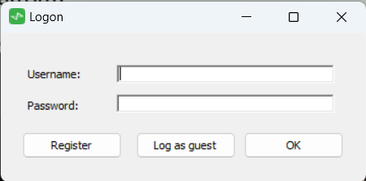When users first start out when they run the Jade application, they are prompted with a logon screen in which they can enter their username and password, if they don’t have an account, they can choose to click the register button.

If the user does not want an account, they can select log as guest which will then direct them to the flight list screen.

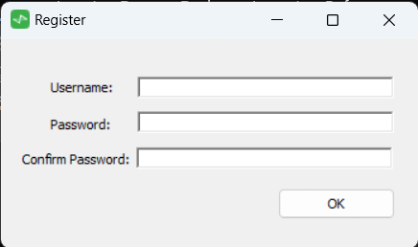**Register:**

When they user has clicked on the register button they are then prompted with a screen that shows them to enter a new username and password in which will add them to the database as long as they aren’t already on the database.